**SQL - CODING CHALLENGE**

**J502 ABHISHEK.A.G**

**CAR RENTAL SYSTEM**

**DATABASE AND TABLE DESCRIPTION:**

**CarRentalDB**

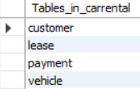

**Vehicle Table**

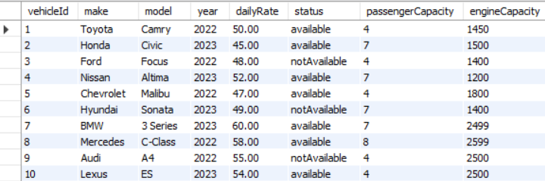

**Customer Table**

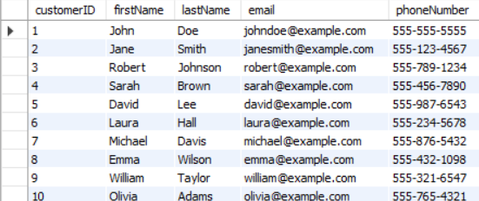

**Lease Table**

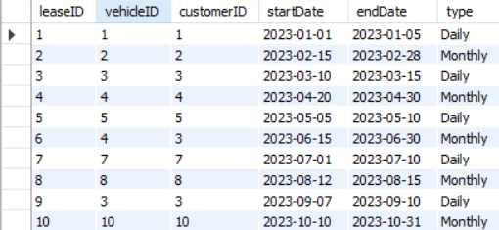

**Payment Table**

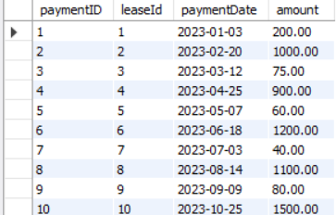

**1. Update the daily rate for a Mercedes car to 68.**

update Vehicle set dailyRate=68 where make='Mercedes';

**2. Delete a specific customer and all associated leases and payments.**

delete from Payment where leaseID in (select leaseID from Lease where customerID = 3);

delete from Lease where customerID = 3;

delete from Customer where customerID = 3;

**3. Rename the "paymentDate" column in the Payment table to "transactionDate".**

alter table Payment rename column paymentDate to transactionDate;

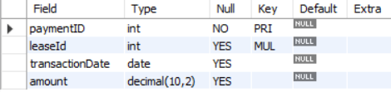

**4. Find a specific customer by email.**

select * from Customer where email='michael@example.com';

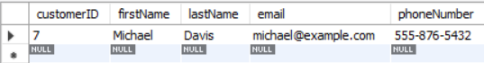

**5. Get active leases for a specific customer.**

select * from Lease where customerId=4 and endDate>=curdate();



**6. Find all payments made by a customer with a specific phone number.**

select p.* from Payment p

join Lease l on p.leaseID=l.leaseID

join Customer c on l.customerId=c.customerId

where c.customerID=5;



**7. Calculate the average daily rate of all available cars.**

select avg(dailyRate) as AVG_RATE from Vehicle where status=1;



**8. Find the car with the highest daily rate.**

select * from Vehicle where dailyRate=(select max(dailyRate) from Vehicle);



**9. Retrieve all cars leased by a specific customer.**

select v.* from Vehicle v join Lease l on v.vehicleId=l.vehicleID where l.customerID=7;



**10. Find the details of the most recent lease.**

select * from Lease order by startDate desc limit 1;



**11. List all payments made in the year 2023.**

select * from Payment where year(paymentDate) = 2023;

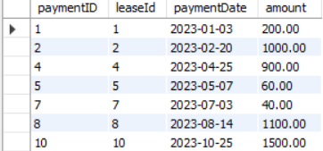

**12. Retrieve customers who have not made any payments.**

select c.* from Customer c

left join Lease l on c.customerID=l.customerID

left join Payment P on l.leaseID=p.leaseID where p.paymentID is null;

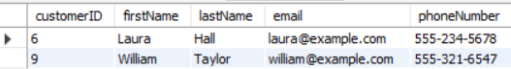

**13. Retrieve Car Details and Their Total Payments.**

select v.vehicleId,v.make,v.model,v.year,v.dailyRate,sum(p.amount) as tot_Payment from Vehicle v

join Lease l on v.vehicleID=l.vehicleId

join Payment p on l.leaseID=p.leaseID group by vehicleID;

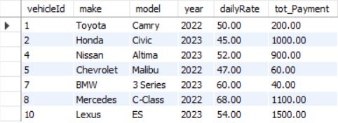

**14. Calculate Total Payments for Each Customer.**

select c.*,sum(p.amount) from Customer c

join Lease l on c.customerID=l.customerID

join Payment p on l.leaseID=p.paymentID group by customerID;

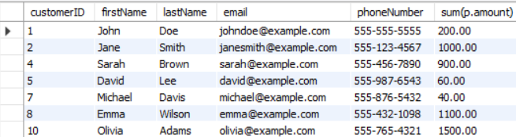

**15. List Car Details for Each Lease.**

select l.leaseID, l.customerID, l.startDate, l.endDate, l.Type, v.vehicleID, v.make, v.model, v.year, v.dailyRate from Lease l

join Vehicle v on l.vehicleID = v.vehicleID

order by l.leaseID;

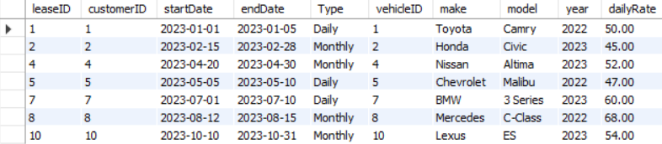

**16. Retrieve Details of Active Leases with Customer and Car Information.**

select l.*,c.*,v.* from Lease l

join Customer c on l.customerID = c.customerID

join Vehicle v on l.vehicleID = v.vehicleID

where l.endDate >= curdate()

order by l.startDate;



**17. Find the Customer Who Has Spent the Most on Leases.**

select c.customerID,concat(c.firstName,' ',c.lastName) as customer_name,sum(p.amount) as tot_payment from Customer c

join Lease l on c.customerID=l.customerID

join Payment p on l.leaseId=p.leaseID

group by customerID order by tot_payment desc limit 1;



**18. List All Cars with Their Current Lease Information.**

select v.*,l.* from Vehicle v join Lease l on v.vehicleID=l.vehicleID where l.startDate>curdate();

